Introduction 2
Installation 2
Units 2
Files 3
Relays 3
Convert 4
Automatic 4
Test 5
Options 5
FTP 6
Clients 7
Command line options 7
Support 7
Index 9

Introduction
Tek-Link downloads data from Envirotek radio systems, and saves the data in a separate, comma-delimited file for each Enviropro soil moisture unit.
This format allows the data to be read by Microsoft Excel, M-Log, Probe for Windows and other software.
The files can also be uploaded to a web site using ftp, so that an M-Log user can automatically download the latest data from the web.

Installation
Insert CD and run D:\TekLink\SETUP.EXE
An upgrade can be installed by running D:\TekLink\UPGRADE.EXE
Install sample data separately by running D:\TekLink\TSDATA.EXE.

Units

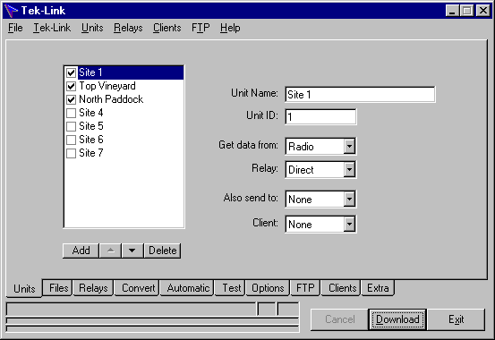
Add a unit for each Enviropro field unit that has been installed.
A unit has a name (any text you like), and a Unit ID that will be supplied by Envirotek.
Only checked units will be downloaded automatically.
Data for each unit could come from radio, or from a handheld data collection unit, or be downloaded from an internet ftp server.
Radio links might need a relay - see Relays.
After downloading, the data file can also be sent to an ftp site on the internet, to allow another user to access the data.
If you are handling data for different clients or farms, the data file scan be saved in separate folders - see Clients.

Files
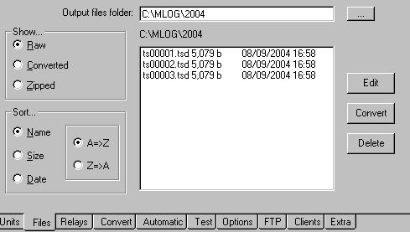
Use the <...> button to locate the folder where the output files will be left.
The default is C:\Mlog, but a different folder could be created with Microsoft Explorer. You could consider using a different folder each year - for example C:\Mlog\2004.
The raw download files, the converted files or the zipped files can be displayed, with their date and size. Files can be viewed (or edited), and deleted.
Raw data files that have been downloaded using MS.HyperTerminal (or some other communications software) can be converted.

Relays
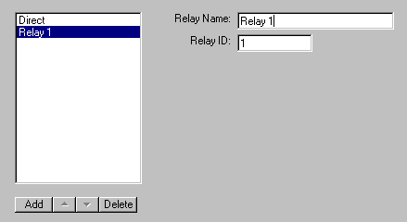
Radio relay units may be required for radio transmission to distant units.
Create a relay for each relay that you have installed. The name can be any text you like; the Relay ID will be supplied by Envirotek.
On the Units tab you will need to allocate units to their relay.

Convert
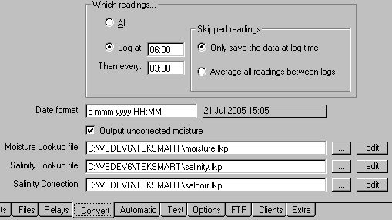
The raw data downloaded from Enviropro needs to be converted into soil moisture, salinity and temperature. In addition, only data at intervals can be saved. Typically Enviropro records every 15 minutes, but you may want to only save data every hour.
The date format uses standard Microsoft formatting codes, and allows for the date to be output in a wide range of styles.
The calibrations equations are in lookup tables, allowing for non-linear equations. The tables will be supplied by Envirotek, but can be edited.

Automatic
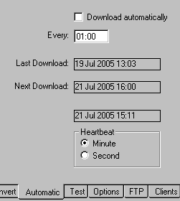
Data can be automatically downloaded at intervals. The default interval is every hour, but it can range from every 10:00 minutes to every 24:00 hours.
If Automatic is checked, when Tek-Link is run it may immediately start to download if it is past the due time.
Tek-Link can be minimised, running in the background.

Test
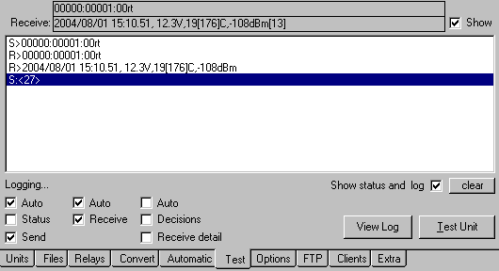
Various options allow for sending any error messages during transmission to be sent o a log file. In addition the user can see the messages on the screen.
You can also see the data as it is transmitted between the PC and base unit.

Options
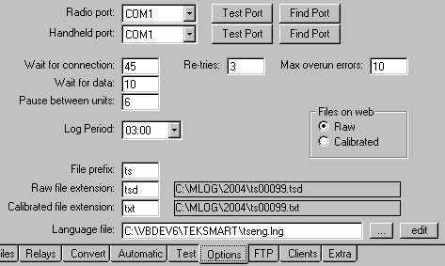
A Envirotek base unit is connected to a serial port on the PC, and the port needs selecting. Serial ports are normally COM1 or COM2, but USB connectors can be used and they may be any COM number.
<Test Port> will see if a valid Envirotek base unit is connected.
<Find Port> will check all ports on your PC, looking for an attached Envirotek base unit.
The timeout period (default = 25 secs) is the maximum amount of time that Tek-Link will wait for a reply from a Envirotek base unit.
There will normally be a delay of up to 20 seconds while the base unit is interrogating a field unit.
The log period is the logging interval of the field units - default is every 00:15 minutes , but it can be up to 3:00 hours.
Use TekLinkMenu/SetLogPeriod to change the logging period. in the field units.
The File prefix (default = ts) is added to the beginning of file names.
The raw file extension (default = tsd) is the extension used for all downloaded raw data files.
The calibrated file extension (default = txt) is used for the filename after conversion. An extension of csv would allow the converted files to be opened by Excel.
Files uploaded by ftp to the web can be either the raw data, or the calibrated web.

FTP
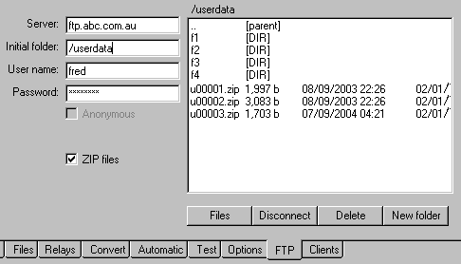
After downloading and converting, the data files can be uploaded to a web site. This would allow an M-Log user anywhere in the world to automatically see the latest data.
The Server, Folder, User Name and Password will be supplied by your ISP - you will need full rights to the folder. The folder is where the data files will be saved. If you are using separate folders for each client use ‘create client folders’ on the Clients tab.
Files can be zipped before uploading
Use <files> to see files on the server. Double click on folders to navigate. New folders can be created, and files and folders can be deleted.
Because file names in Unix are case-sensitive, all files and folder names on the server are in lower case.

Clients
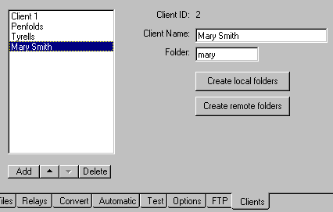
A consultant could be downloading many units at a central location, but may need to keep the data files in a separate folder for each client or grower.
The client name can be any test you like; the client folder is the name of the folder relative to the main folder. If the main data folder is C:\Mlog\2004, and a client folder is Mary, the actual folder will be C:\Mlog\2004\Mary on the local PC, and initialfolder/mary on the ftp web site.
Folders on the local PC (and on the web site if you are uploading), need to be created. on the Clients tab.
On the Units tab, allocate each unit to a client to enable saving data in a separate folder.

Command line options
The following switches are recognized if entered on the command line. Right-click on the shortcut that runs Tek-Link, and choose properties.
e.g. TekLink.exe /D /Q will run the software, convert, and quit.
/D Download, convert and upload to web site
/M Minimize Tek-Link
/Q Quit Tek-Link

Support
Free telephone, fax and email support for the software is provided for 3 months. After that time you can either take out an annual support contract, or pay a charge for each problem.
Software updates and other files for downloading are at...
http://www.rsne.com.au/mlog/upgrades.htm
http://www.rsne.com.au/teklink/upgrades.htm

Envirotek
PO Box 380, Mount Compass, SA 5210, Australia
T: +61 (8) 8556 6848
E: sales@envirotek.com.au
W: www.envirotek.com.au

Research Services New England
8/16 Nicholson Street, Balmain, NSW 2041, Australia
T: +61 (2) 9810 3563
F: +61 (2) 9810 3323
E: support@rsne.com.au
W: www.rsne.com.au

Index

A
automatic, 2
automatic download, 4
C
calibration equations, 4
checked, 2
client, 3, 6
Convert, 4
D
date format, 4
download, 2
F
folder, 3, 7
ftp, 6, 7
ftp, 2
H
handheld, 2
I
initialfolder, 7
Installation, 2
L
logging interval, 4
R
radio, 2
relay, 2, 3
U
unit ID, 2
upgrade, 2

