M-Log can graph data from the HH2 hand-held portable data recorder, manufactured by Delta-T Devices. The HH2 can read and record data from the Profile Probe (PR1), ThetaProbe (ML1 & ML2), and Equitensiometer (EQ1 & EQ2).
The PR1 has 4 (or 6) capacitance soil moisture sensors on a rod which can either be taken from site-to-site to record readings, or it can be left at a single site with a logger. The HH2 is only used if the PR1 is used in portable mode - if the PR1 is left at a site with data recorded by a fixed logger M-Log needs to be configured for that logger.
Data is downloaded from the HH2 and then distributed to a separate data file for each site with...
- Use LoggerMenu/Upload/DeltaT-HH2
- Click <Upload>
- Click <Process>
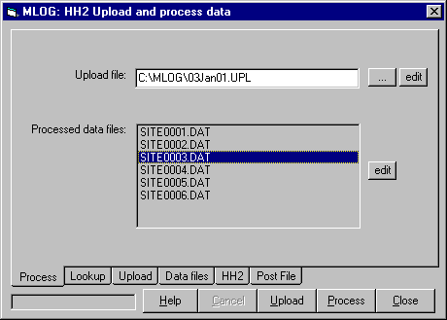
You will now be able to graph the data by clicking on each sensor.
Installation and configuration is described below- for further details see the M-Log manual.
Installing M-Log
- Install M-Log from CD (D:\MLOG\SETUP.EXE) with...
- Click on Start
- Choose Run
- Enter D:\MLOG\SETUP.EXE (or use <Browse>)
- Follow the setup wizard with Next, Next
- If supplied, install M-Log upgrade from disk (A:\UPGRADE.EXE)
3. Run M-Log from Start/Menu or icon.
The sample database of loggers and sensors will be listed - click on a sensor to plot the sample data.
Installing Licence
M-Log needs to be licenced to allow changes you make to be saved.
- Use FileMenu/Licence
- Click <Install>
- Email or fax the PC Serial number and you will be sent a password.
- Enter the password and click <Activate>
Create a new database for your loggers
You can create a new database for the PR1 data…
Use FileMenu/New/Database, and choose C:\MLOG\MLOG1.MDB.
Alternatively you can add new loggers to an existing M-Log database. New loggers and sensors will be created after readings are uploaded.
Taking readings with the PR1 and HH2
- Connect the PR1 to the HH2.
- Enter the site number as DeviceID (1-255) with...
<Set> Data <Set><Up> Erase <Set> <Set>
- Record the data with... <Read> Save data ? <Set>
Uploading
- Connect the HH2 to the PC with the RS232 cable.
- Run M-Log, and use LoggerMenu/Upload/DeltaT-HH2.
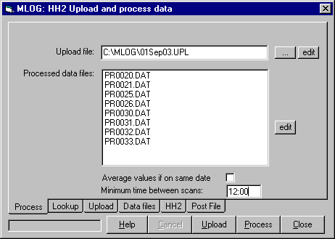
- On the Upload tab choose the correct port (default = Port 1)
- Click <Upload>
The data is now be in a file ddMMyy.UPL, which can be checked using edit.
Process
- On the Lookup tab choose the method of identifying each site.
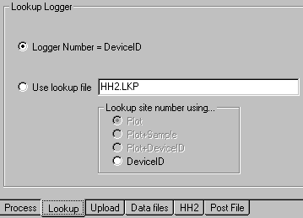
If you use LoggerNumber=DeviceID new loggers and sensors will be created automatically, with the new logger number the same as the DeviceID entered into the HH2 at each site. (lookup file will not be used)
2. Click <Process> to distribute the uploaded data to a separate file for each site - it can be checked using <edit> on the Process tab.
If a logger does not exist with the same number as the DeviceID number, you will be prompted to create a new logger (site).
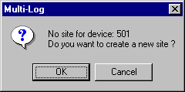
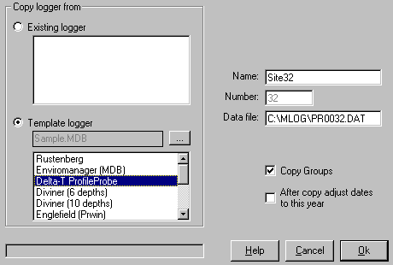
You can create the new logger by copying either a template logger, or one of your own existing loggers that has already been customised.
If more than one tube is installed at a site, and each tube is given the same DeviceID, the data from the tubes will be averaged.
Notes
Averaging several tubes at the same site - if you are taking continous readings at a single site each set of readings must be more than 'minimum time between scans' apart, otherwise all the readings will be averaged.
If multiple theta probes are being used at each site the HH2 is connected to each sensor in turn, and a separate DeviceID number entered. A lookup file must be used, with the column (or depth number) of each sensor entered in the lookup file. If continuous readings are being taken at the same site each set of readings must be more than 'minimum time between scans' apart.
HH2 Commands
After uploading and processing the HH2 memory is cleared with...
<Set> Data <Set><Up> Erase <Set> Erase ? <Set>
The HH2 is configured for use with a PR1 (access tube) with...
<Set><⬇> Device <Set><⬆⬆> PR1 <Set>
The HH2 is prepared for uploading with...
<Set><⬆> Remote <Set>
Use LoggerMenu/Upload/Delta-T HH2 <GetStatus> to show the current battery and memory status of the HH2.

Research Services New England
8/16 Nicholson Street, Balmain, NSW 2041, Australia
T: +61 (2) 9810 3563 F: +61 (2) 9810 3323
E: support@rsne.com.au W: www.rsne.com.au
Delta-T Devices
128 Low Road, Burwell, Cambridge, CB5 0EJ, U K
T: +44 (1638) 74 2922 F: +44 (1638) 74 3155
E: sales@delta-t.co.uk W: www.delta-t.co.uk

