Multi-Log
Multi-Log 1
Loggers 2
Sensors 2
M-Log Database 3
Creating Loggers and Sensors 4
Data Type 4
Logger Name and Number 5
Text Data 5
Non-Text Data 7
Calculated Sensors 7
Creating a new table 8
Logger Details 9
Data Type 9
MBB file 9
Sensors 10
Graphs 10
Limits 10
Smoothing 10
Rate of change 11
Integration 11
Predictions 11
Text files 12
Lookup file 13
Graphing 14
Scales 14
Saving Graph Scales 14
Reset Scales 14
Graph Options 15
Graph Extra 15
Refresh Data 15
Current reading 15
Upper and Lower Limits 16
Irrigation Scheduling 17
Groups 18
Uploading 19
Fixed Loggers 19
Portable Loggers 19
Diviner 2000 20
Trase 21
Delta-T HH2 Portable Logger 22
Microscan 23
Monitor Sensors 23
Campbell Scientific 23
Measurement Engineering Australia 24
EnviroManager 24
Soil-Spec Tensiometer 24
Environmental Information Technology (EIT) 24
Printing 26
View and edit data 26
Options 26
Backup 26
Licence 26
Contacts 27

Multi-Log can graph data from a wide range of data loggers from different manufacturers. The data can be graphed separately, or overlaid on the same graph. Data from different loggers, recorded at different times, can be plotted on the same graph.
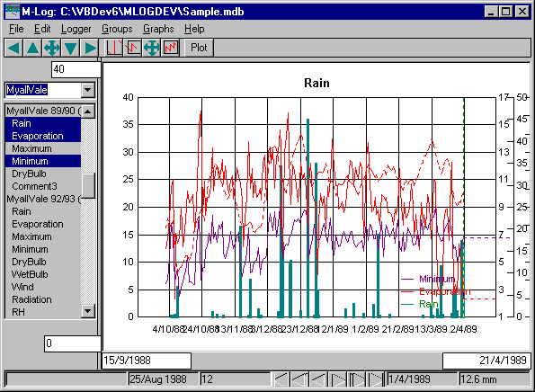
To plot a graph click on the sensor in the list on the left side of the screen - use <ctrl> or <shift> to graph more than one sensor.
M-Log can also upload data from loggers.

Loggers
A data logger is an electronic device that measures data from Sensors, and then records the data for later Uploading to a PC for viewing and analysis.
At intervals of, say, 1 hour, the logger 'scans' the sensors and records their values. The data is later transferred, or uploaded, to a computer and saved in a file. The file may be a text file that can be read by M-Log, or it may be saved in the logger’s own database. M-Log may be able to read this data format, or the database usually has a facility to export the data as a text file, which M-Log can then read.
M-Log saves information about any number of loggers and sensors in its own database.

Sensors
Each sensor has a transducer that measures some physical parameter such as temperature, humidity or soil moisture, converts the value to an electrical signal which is sent down a wire to the logger. The electrical signal may be voltage, current or frequency; and will need to be scaled from electrical units to user units. The scaling, or calibrating, is sometimes done in the logger, or it may have to be done by M-Log. The manufacturer of the sensor may supply the scaling factors, or the user may have to calculate them.

M-Log Database
The information about loggers and sensors is saved in a database - the actual data is saved in text files or in the logger’s own database. M-Log is supplied with an example database of different types of loggers - you can either add loggers to this database or create a new database.
Use FileMenu/New/Database to create your own database - you will be prompted for a new file name (default = MLOGnnn.MDB).
Use FileMenu/Open to open an existing M-Log database - the last database used will be opened automatically next time M-Log is used.
When you create new loggers they can be copied from your current database, or from a database of template loggers and sensors (default = TEMPLATE.MDB). If M-Log is upgraded it will be supplied with a new version of TEMPLATE.MDB, so if you want to have your own template database it should be called something else.
Use FileMenu/Save As to save the database under a new name.
Use FileMenu/CheckDatabase to validate the current database. As M-Log is upgraded new features will be added which may require new data; and if folders or data files are re-named or moved M-Log will need to re-attach the files.

Creating Loggers and Sensors
Use FileMenu/New/Logger to create a new logger and sensors.
A wizard will run and ask various questions, and at the end the new logger and sensors will be created. They can be customised later, and new sensors added, using LoggerMenu/Details. Before running the wizard you should know the name of the file which contains data from the logger.
The wizard will first ask if you want to...
- Create a logger from scratch
- Copy an existing logger and its sensors.
- Copy a template logger and its sensors.
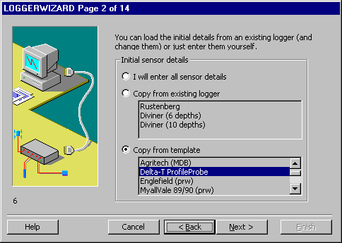
By choosing copy all you will have to do is to give the logger a new name and the name of the data file where the data is stored - all other details will be copied from the existing logger and its sensors.
The existing loggers can come from either the current database, or from a template database (default = TEMPLATE.MDB, set on LoggerMenu/Options - see Options).

Data Type
M-Log can read data in various formats, including MDB files, text files and PR4 format files.
MDB format is very flexible, because as well as reading its own data files it can also link or attach to other data base formats such as Paradox and dBase.
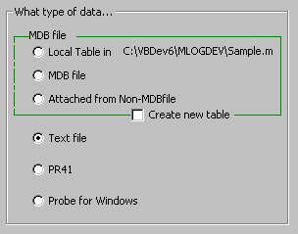
Probe for Windows data is also saved in MDB format, and will be attached to the M-Log database.
See Data Type for more details.

Logger Name and Number
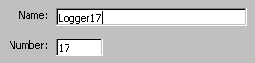
The logger needs a name (default = LOGGERnnn) and a number. The name can be anything you like, and the number is only used to sort the loggers.

Text Data
If the data type is text (i.e. ascii) you will be asked for details of the file format.

Data File
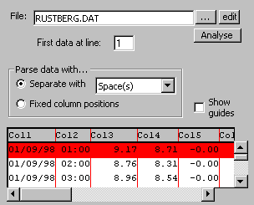
Enter the name of the data file; how the data is separated on each line (typically with a comma or tab); and what line contains the first actual data (and not headings).

Date
Enter where the date information is located on each line.
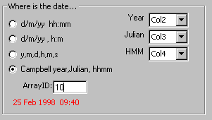
Logger manufacturers output the date in various formats - some will output date and time as a single item, sometimes the date is separate from time, and sometimes the year, month, day, hour, minute are all separate. There may also be problems with the day/month or month/day order - M-Log will import dates and times using the setting chosen by the user with Start/ControlPanel/RegionalSettings/Date.

Selecting and scaling
Select which of the data items on each line is to be graphed.
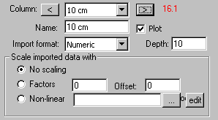
The data may be numeric (normally), or text or date/time.
The data can be ‘scaled’ as it is read, with either a linear equation or with a non-linear lookup table.
See Text files for more details of formats of text data files.

Non-Text Data
If the data type is attached from non-MDB file you will be asked to choose the foreign format (like Paradox) from a list.
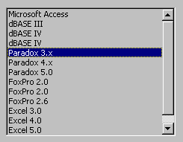
You will then be asked for the name of the data file...
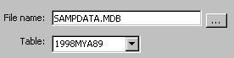
If the data type is MDB format or Probe for Windows you will be asked to enter the name of the MDB file, and then choose the table in the MDB file where the data is stored (a single MDB file can contain many tables). For Probe for Windows the MDB file will be the season file (e.g. 2000DATA.MDB) and the table will be SITEnnn where nnn is the site number.
If the data type is PR41 you should enter the name of the NPS file for the site - this will be FarmShortName+SiteNumber.NPS.
If the data type is other the table name will default to be the name of the data file, because other databases typically have a separate file for each table.
You will then be asked to choose which of the actual data items (called fields in database jargon) you want to graph. A name for each sensor will be suggested, which can be changed.
In order to graph against time, M-Log needs to know the date and time the data was recorded. If the data type is Probe for Windows or PR4 then M-Log knows where the date is saved, but for other formats you will need to choose the field(s) where the date information is saved.

Calculated Sensors
M-Log can have virtual sensors, which will calculate values using data from other sensors. For irrigation scheduling the total water content in a root zone can be calculated if the volumetric soil moisture is recorded by sensors installed at various depths. If you choose add root zone sensor, and enter the root zone extents and the depth of each of the soil moisture sensors, a root zone sensor will be created - see Irrigation Scheduling for more details.

Creating a new table
M-Log can also create a new table for your data. A table has columns (or fields), each corresponding to a different data item, and many rows, each row being the data for a particular date/time.
To create the table M-Log needs the table name (default = LOGGERnnn), a field name for each of the sensors (default = FIELDnnn); and the data type for each of the fields (default= double). M-Log will also create extra fields for the date; for comments to be added by the user; and for a unique ID number for each record.

Logger Details
After a logger and its sensors have been created they can be changed using LoggerMenu/Details. The data file can be changed, and sensors can be added, deleted and customised. Loggers can be made active so that they will display in the main graph list - see LoggerMenu/View/Active.
See Creating Loggers and Sensors for more details.

Data Type
M-Log can read MDB; text; PR41 or Probe for Windows files. MDB files are very flexible because they can also read other database formats such as Paradox and dBase.
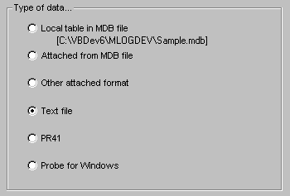
A local table must be in the M-Log database - data would not normally be saved in this file.
An attached table will be in another MDB file, with the file name entered on the MDB tab - EnviroManager can save data in this format.
If you choose other attached you will also need to select the database type and enter the filename on the MDB tab.
PR41 have special numeric data files, and the full and refill points will also be imported.
Probe for Windows data is in MDB format, but by choosing this option the date is automatically set and the upper and lower limits (full and refill) are also imported.

MBB file
The MDB section is only applicable if the data is in MDB format, or attached through MDB format.
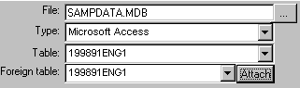
File is the name of the MDB or other data file (e.g. Paradox).
Type is the type of database.
Table is the name of the table as used by M-Log (could be different from the ‘foreign’ name). For non-MDB formats it will also be the name of the data file.
Foreign is the actual name of the table in the file (MDB files can contain many tables). For non-MDB formats it will be blank.
To avoid problems if attaching two tables with the same name MDB format allows tables to be attached with an ‘alias’ name. If required the <attach> button will attach the table.
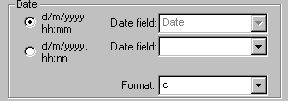
Date field is where and how the date information is located in the data file.
Format controls the way the date will be displayed on the horizontal axis.
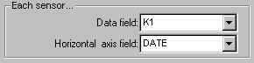
Data field is where the sensor data is located.
Horizontal axis is normally the DATE.

Sensors
The name of the sensor (which will appear on graphs and in sensor lists) and the sensor number (which controls its order in the list) can be changed.
The number of decimal places and units (e.g. DegC) controls how the value will be displayed on graphs. Numeric formatting uses standard Microsoft format codes.

Graphs
Most of the graph options are more conveniently set with GraphMenu/Options - see Graph Options.
Graphing of data with a value of 0 (e.g. rainfalls) can be suppressed.
To allow data from different years to be compared by overlaying, graphs can be moved horizontally by adding (or subtracting) an offset from the date values. For example, to compare weather data from last year the data needs to be moved horizontally by 365 days.

Limits
The upper and lower limits can also be set with a right mouse click on the graph, or with GraphMenu/Options - see Upper and Lower Limits.

Smoothing
Use GraphMenu/Extras/Smooth to plot a smooth line through the data.
Smoothing can be either
- A moving average with a user entered 'window'. A 7 day window will give the average of all readings in a week, and 1 day will give the average of all data in a day
- A digital filter with a user entered factor. The factor (default=0.05) can be adjusted to give more or less smoothing.
- A polynomial with user entered order
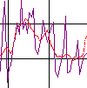
Smoothing can only calculated if the data has been recorded at equal time intervals.

Rate of change
Use GraphMenu/Extras/Rate to plot a line showing the rate of change of the data.
The rate of change can be based on the difference between...
- successive readings
- readings a number of days apart.
For example, an indication of effective soil moisture increase would be based on the change of readings taken 24 hours apart, rather that the change between successive readings taken every hour.
The rate line needs special scale values with an axis on the right side of the graph.
Rates are calculated as change per day, and displayed with an extra decimal place.
If the data is not at equal time intervals the rate can only be calculated using successive readings.
Rate-of-change can be displayed as either positive or negative. A user could think that a rising temperature is positive; but that soil moisture that is rising is negative. Use LoggerMenu/Options to set whether rates of change should be displayed and entered as positive or negative numbers.

Integration
Use GraphMenu/Extras/Integration to plot a line showing the integration, or summing, of the data.
Integration allows you to calculate, for example, growing degree days. Degree days are used to measure the total heat units during the year - typically it is the difference between the actual temperature and a base temperature, multiplied by the time.
Factor is the base value above which the data will be integrated.
The integration line needs special scale values with an axis on the right side of the graph.

Predictions
The date and time when a sensor will reach the lower limit (if it is increasing) or the upper limit (if it is decreasing) can be calculated and plotted.
The rate of change of the data that will be used to calculate the predicted date can be from…
- Last 2 readings.
- The rate of the smooth line (see Smoothing).
- The rate from the rate line (see Rate of change).

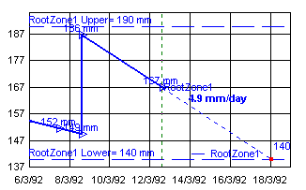
The predictions are plotted with GraphMenu/PlotPredict.
See Irrigation Scheduling to calculate the amount of water that will be required to bring the sensor back to the upper limit.

Text files
The text file can be transferred from the logger to the PC using...
- M-Log (see Uploading)
- The logger’s own communications programme
- Exported from the logger’s data programme.
Use the <TextImport> tab to enter the name of the data file, and how the data is separated. Text files typically have a line of data corresponding to a scan taken of each of the sensors at a certain date and time. The line will have the date and time, and the value of each of the sensors. A comma, tabs or space(s) may separate the items; or they can be at fixed positions, and M-Log will parse the incoming data into columns. The first line(s) may be header information about each of the sensors.
When creating a new logger without copying an existing logger (see Creating Loggers and Sensors) M-Log will attempt to analyse the format, but this may need to be changed. The file can be looked at with <edit> to work out which is the first data line and what separates the data items.
Use the <TextDate> tab to specify where the date and time is on each line. There is no standard method to record date and time. Some loggers will output 1/12/1998 12:00, some as comma delimited e.g. 1998, 12, 1, 12, 0, and others as days since Jan 1st e.g. 335, 12:00.
The <TestImport> tab will show how the lines are being separated.
Use the <SensorImport> tab to specify the column and the import format (numeric, text, or date/time information) for each sensor. The data can be scaled, or calibrated, as it is imported because some loggers only record raw numbers. M-Log can use either a linear equation of the form…
Value = RawNumber * Factor + Constant
Or a non-linear lookup file can be used.

Lookup file
Lookup files are text files with 2 numbers on each line - the raw value followed by the desired value after scaling.
0, 0.00
120, 2.00
210, 5.00
310, 10.00
415, 15.00
510, 20.00
610, 25.00
720, 30.00

M-Log will use linear interpolation to calculate intermediate points, so the closer the points the more accurate the scaling. There is no limit to the complexity of the calibration equation using lookup files.

Graphing
To graph a sensor click on the sensor name in the list on the left side of the screen. To graph more than one sensor use <ctrl> or <shift> as you click on the list.
Use LoggerMenu/Show/Active to only show active loggers - they can be activated with LoggerMenu/Details.
Use LoggerMenu/Show/Loggers to hide the logger name and only show sensors.

Scales
The graph scales can be changed by...
- Entering new values in the text boxes near the axes.
- Use the pan buttons (arrows) on the top toolbar
- Zoom using the mouse and dragging a rectangle over the area of interest.
The pan out button will zoom out - the undo button will go back to the previous scales.
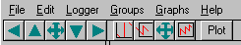
Top tool bar
Use GraphMenu/SetScale/MaxMin (or the button) to set the scales to the actual maximum and minimum values of the data.

Saving Graph Scales
Use GraphMenu/Scales/Local/Global to set whether the graph scales are saved locally with each sensor, or saved globally so that all graphs are plotted to the same scale.
When overlaying graphs with <Ctrl+Click>, the first sensor selected is the main sensor - this sensor will always plot with on the left scale (either it’s own local scale or the global scale) but the other sensors can be plotted either...
- to the same scale as the main sensor using the left scale.
- to the sensors own scale on the right scale.
Use GraphMenu/IfOverlaid to set how a sensor is plotted if it is overlaid. The right hand scale values can be set on GraphMenu/Options; or by first setting the values on the screen and then use GraphMenu/SaveScaleAs/RightHandAxis.

Reset Scales
Use GraphMenu/SaveScales/Reset (or button) to save the current scales as the reset scale
and GraphMenu/ScalesToReset (or button) to return the scales to the reset values.
The reset scales let you easily return to a known scale after you have zoomed in on the graph. The reset scales could be set to have the dates set to be the last two weeks, and the vertical scale to the maximum and minimum values.

Graph Options
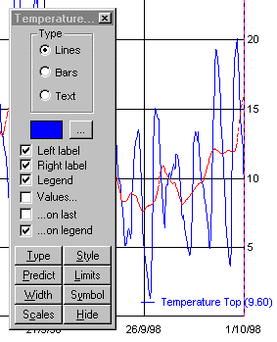Use GraphMenu/Options to set various graphing options for each sensor - as changes are made the graph will re-draw so you can see the effect.
Each sensor can be plotted using its own colour and line style; a symbol can be plotted at each point; a label can be printed at each end of the line, and a legend. The actual value of the data point can be printed above each point, on the last point, or on the legend.
The data can be plotted as a line, or as a bar chart (e.g. rainfalls), or if it is text M-Log will draw a horizontal line with a solid circle to indicate a text is available. Double click on the circle to read the comment.
Upper and lower limits can be set for each sensor - they can also be set using a right-mouse click on the graph. A warning circle can be plotted if a sensor goes above or below the limit. (Also use GraphMenu/Upper/Lower).
A prediction line can be plotted showing when a sensor will reach the lower (or upper) limit. Two predictions are made...
- using the calculated rate-of-change of the sensor.
- using a user-entered rate-of-change.

Graph Extra
Extra, calculated, data can be plotted for each sensor.
- Smooth - a running average over a user-adjustable number of days (see Smoothing).
- Rate-of-change - calculated from the change in the data (see Rate of change)
- Integrated - the area under the line (e.g. growing degree-days) see Integration.
Use LoggerMenu/Details to set the calculation options.

Refresh Data
If a logger is updating the data file in real-time (e.g. EnviroManager) M-Log needs to be told to re-read the data file. LoggerMenu/RefreshData will re-load the data and re-plot the graph.

Current reading
Use GraphMenu/CurrentDate to show a status bar at the bottom of the screen with the value of the current reading, and also the value on the graph as the mouse is moved.
Use the VCR buttons to move from reading to reading.

Upper and Lower Limits
The upper and lower limits can be set by the user, using either GraphMenu/Options, or with a right click on the graph. These limits can be plotted as a horizontal line on the graph; and a red warning circle can be plotted on all data points that are above the upper or below the lower limit. The limits are also used for Predictions and Irrigation Scheduling.

Irrigation Scheduling
A logger recording soil moisture from a number of sensors at different depths can be used to schedule irrigations. The value of the volumetric soil moisture needs to summed (or integrated) down the soil profile using the depth that each sensor is buried. This is done with a calculated sensor with the formula ROOTZONE. Any number of root zone sensors can be created with <AddRootZone>, but only one can be used as the scheduling sensor.
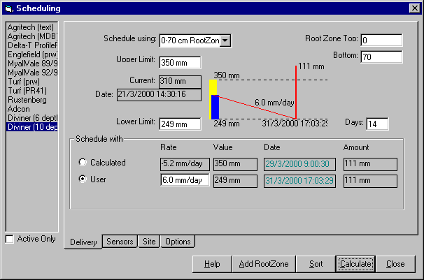

The root zone top and bottom must be entered. All sensors that are located at a depth between the root zone extents (and with a depth greater than 0) will be included in the total water content.
Any of the root zones can be used to schedule the next irrigation (in fact any sensor could be used to schedule). The scheduling sensor must have an upper and lower limit entered, and M-Log will then calculate the date when the sensor will reach the lower (or upper) limit.
The amount of water that will need to be applied to bring the sensor back to the upper limit is also displayed. The amount is...
Amount = (Upper - Lower) * FACTOR + CONSTANT
Where Factor (default = 1) and Constant (default = 0) can be entered by the user.
If the area is entered (in Ha) the volume of water can be displayed, and if the pumping rate is entered the watering time can be displayed.

Groups
Sensors can be allocated to a group, and all the sensors in the group will be selected automatically by choosing the group from the drop-down above the list of sensors.
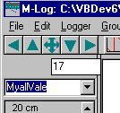
New groups can be created by selecting the sites with Click and Ctrl+Click in the list of sites and then use GroupsMenu/SaveAs. Groups can edited (and created) with GroupsMenu/Edit.
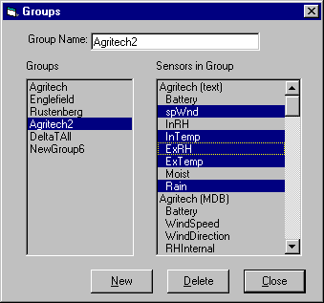
Use <New> to create a new group. Click on a group to select a group for editing. Click and Ctrl+Click on a sensor to add or delete sensors from the group.

Uploading
M-Log can upload data from some data loggers. Uploading is only required if the data files have not been already been created by the logger’s own software. Uploading may also needed to process data that has already been uploaded to the PC (e.g. Diviner 2000).
To upload use LoggerMenu/Upload/Loggers , and then choose a logger.
Some portable devices, such as the Delta-T HH2 or the Sentek Diviner2000, record data from more than one site. To upload from these portable devices use LoggerMenu/Upload and choose the device, or choose portable for generic devices.

Fixed Loggers
Use LoggerMenu/Upload/Loggers, chose a logger, and then press <UPLOAD>.
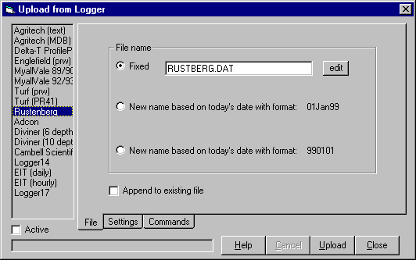
The data can be uploaded directly to the data file that will be read by M-Log - if this file already exists data can be appended to the file.
It may be more appropriate to use the generic portable upload so that the data can be checked before being appended to the end of the final data file
The serial port needs to be chosen (default = port 1), and the baud rate set according to the logger specification.

Portable Loggers
For these devices the data must first be uploaded to an upload file, and then the data distributed to a separate data file for each site. In this section the word site refers to a physical location in the field and corresponds to an M-Log logger.
Some portable devices, such as the HH2, Diviner2000 and Trase, have their own special upload forms - other devices (such as the Microscan) are able to share a generic upload form.
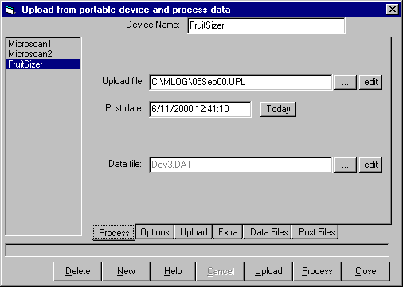
The generic devices require you to choose the baud rate and to enter commands that are required to wake-up the logger and to dump data. Microscan, for example, uses 9600 baud and requires a ‘p’ to dump data.
Press <Upload> to transfer the data - it will normally be saved in a file called ddMMMyy.UPL, where ddMMMyy is today’s date.
After the data has been transferred use <Process> to distribute the data from the upload file to a separate file for each site.
To do the processing M-Log needs to be told the name of the final data file for each site, which must be entered by the user in a lookup file. The lookup file is a text file that can be edited with Notepad and contains one line for each site. If the lookup file does not exist it will be created; and if a new site is found that is not in the lookup file a new line will be added for the new site and you will be asked to check the entry. The lookup file format varies from device to device, but typically looks like...
ID, SiteNumber, DataFile
1, 101, SITE101.DAT
2, 102, SITE102.DAT
Where ID is the number used by the portable device, SiteNumber must be present but is not used by M-Log, and DataFile is the name of the data file for the site.

Diviner 2000
The Diviner2000 is a portable instrument manufactured by Sentek that is taken from site-to-site. It has a single capacitance sensor on a rod that is lowered into a tube in the ground and records soil moisture at different depths. The lookup file needs the Diviner2000 tube number and the name of the corresponding data file.
Using a programme provided by the manufacturer (DivinerUtilities.Exe) the data is first backed-up from the Diviner2000 to the PC, and then exported to CSV files. There will be a separate CSV file for each site and for each time the data is exported (a typical file name is: Diviner Backup 20 Sep 1999 (Pro99).csv).
M-Log processes all the CSV files (use <Process>) into a single data file for each site, with a format similar to the CSV files...
Time, 10cm, 20cm, 30cm, 40cm, 50cm, 60cm, 70cm, 80cm, 90cm, 100cm
19 Aug 1999 11:12:29, 28.827166, 32.604797, 28.906691, 8.764552, 4.833654, 1.388091, 0.650105, 2.577018, 35.290493, 30.491446
19 Aug 1999 11:13:16, 28.365362, 33.111546, 28.483774, 9.218303, 4.956022, 1.341284, 0.646405,
Because M-Log processes all files in the backup folder, the data in the Diviner2000 can be cleared after it has been backed up to the PC.
If data for a site is found with the same date (because the Diviner2000 has been backed-up more than once) the data is not added to the final data file.
If more than one tube is installed at a site the readings can be averaged if they were taken on the same day. Each tube will have a separate Diviner2000 tube number but the lookup file will have the same data file for each of the tubes.
The lookup file needs to relate Diviner2000 tube numbers to a data file, with format...
DivineTube, SiteNumber, DataFile 'Comment
1 , 101, C:\MLOG\DIVINER\SITE101.DAT 'tube 1 => SITE101.DAT
2 , 102, C:\MLOG\DIVINER\SITE102.DAT 'tube 2 => SITE102.DAT
3 , 103, C:\MLOG\DIVINER\SITE103.DAT 'tube 3&4 => SITE103.DAT
4 , 103, C:\MLOG\DIVINER\SITE103.DAT 'tube 3&4 averaged
If a tube number is found in a csv file that is not in the lookup file a new line is added with a site number = 9999 (not used by M-Log) and a data file name assembled from a user nominated folder, base name and extension. The lookup file should then be edited to check the entry and the upload file re-processed.

Trase
The Trase from Soil Moisture Equipment Corp measures soil moisture content using time domain reflectometry. The sensors can be either pushed into the soil from the surface, or permanently buried. The unit can be carried from site to site, or left at a single site and act as a logger. There are various models that output the data in different formats. A typical format is...
1,1,Tag,24.8,12.7,40.0,"CON",0,0,"CUN",13.4,"17APR2000","08:41:52",0," ","21E "
1,2,"010201",25.5,13.3,40.0,"CON",0,0,"CUN",13.4,"17APR2000","08:42:35",0," ","21E "
The data can be uploaded using M-Log (the user will need to press <Print> on the Trase), and then the data needs to be processed to distribute it to separate data files for each site.
Each reading is identified in the Trase by a user entered tag. Sensors can be installed at different depths at the same site, so the lookup file needs to allow for more than one sensor to be allocated to each site.
Tag, SiteNumber, Depth, DataFile 'Comment
1, 306, 1,C:\MLOG\TRASE\SITE3456.DAT 'tag=1 to SITE3456.DAT, depth 1
2, 306, 2,C:\MLOG\TRASE\SITE3456.DAT 'tag=2 to SITE3456.DAT, depth 2
3, 306, 3,C:\MLOG\TRASE\SITE3456.DAT
7, 307, 1,C:\MLOG\TRASE\SITE3457.DAT
8, 307, 2,C:\MLOG\TRASE\SITE3457.DAT
9, 307, 3,C:\MLOG\TRASE\SITE3457.DAT
If a tag is found in the upload file that is not in the lookup file a new line is added with a site number = 9999 (not used by M-Log) and a file name assembled from a user nominated folder, base name and extension. The lookup file should then be edited to check the entry and the upload file re-processed.

Delta-T HH2 Portable Logger
The HH2 is a hand-held portable data recorder from Delta-T Devices that can read and record data from the Profile Probe (PR1), ThetaProbe (ML1 & ML2), and Equitensiometer (EQ1 & EQ2). Three separate site identifiers can be entered into the HH2 - PlotID (A-Z), Sample (1-1999, auto-increments but can be changed), and DeviceID (1-99).
The PR1 has 4 or 6 capacitance soil moisture sensors on a rod. The rod can be either taken from site-to-site to record readings, or it can be left at a single site and a logger attached. The HH2 is only used if the PR1 is used in portable mode - if it is being logged the data will be formatted by the logger used.
HH2 data can be transferred to an upload file with M-Log (<Upload>), or with the Delta-T programme HH2READ.EXE. M-Log will give a new name to the upload file based on today’s date with extension UPL - HH2READ.EXE will use extension CSV.
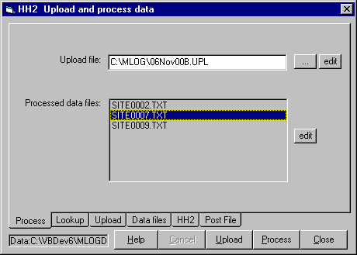
Both methods leave the data in an upload file which must then be processed (<Process>) to distribute the data to a separate data file for each site. The format of the final data file is similar to the upload file...
Date,Sample,Plot,Device,Data1,Err,Data2,Err,Data3,Err,Data4,Err,Data5,Err,Data6,Error
28/03/2001 17:12:44,0001,a,001,31.1 ,A,32.1 ,A,33.1 ,A,34.1 ,A,34.1 ,A,
28/03/2001 17:13:44,0002,b,002,31.1 ,A,32.1 ,A,33.1 ,A,34.1 ,A,34.1 ,A,
28/03/2001 17:14:44,0003,c,003,31.1 ,A,32.1 ,A,33.1 ,A,34.1 ,A,34.1 ,A,
28/03/2001 17:15:44,0004,d,004,31.1 ,A,32.1 ,A,33.1 ,A,34.1 ,A,34.1 ,A,

The Err are data status codes.
M-Log uniquely identifies a site using either...
- Sample plus PlotID (DeviceID is ignored)
- PlotID plus DeviceID (Sample is ignored)
The format of the lookup file needed to configure the HH2 plot, device and sample numbers to the name of a data file is...
Sample,Plot,Device,SiteNumber,Column,DataFile
0001,A,000, 9999 ,1 , C:\MLOG\DELTAT\HH20001.DAT
0002,B,010, 9999 ,1 ,C:\MLOG\DELTAT\HH20002.DAT
0003,C,100, 9999 ,1, C:\MLOG\DELTAT\HH20003.DAT
The SiteNumber is not used by M-Log but must be present. The Column is not used for PR1 data, but can be used to append readings from individual ML2 or EQ1 units to the same data file.
If a site is found in the upload file that is not in the lookup file a new line will be added with a site number = 9999 (not used by M-Log) and a file name assembled from a user nominated folder, base name and extension. The lookup file should then be edited to check the entry and the upload file re-processed.
The HH2 is prepared for uploading with...
<Set><Up> Remote <Set>.
After successfully uploading the HH2 memory is cleared with...
<Set> Data <Set><Up> Erase <Set> Erase ? <Set>.

Microscan
This is a portable single channel logger manufactured by Microscan that can record data from a wide range of sensors. A number can be entered to identify each site.
M-Log can upload from a Microscan, and the upload file needs to be processed to distribute the data to separate data files for each site.
The lookup file will contain the Microscan site number and the corresponding data file.
The Microscan uploads at 9600 baud, and need a ‘p’ command to start dumping data.

Monitor Sensors
Monitor Sensors manufacture sensors and loggers for weather stations. The data is downloaded using single character commands, with the logger outputting a menu. The baud rate defaults to 9600 baud, but can be changed by software.
The output is ascii text, with typical format...
date , time , AN100002, BP100008, SR100026, TA100069, TA100068,
dd/mm/yy, hh:mm:ss, a km/h , b hPa , c W/m² , d °C , w °C ,
16/01/99, 00:00:00, 11.60, 1016.01, 0.00, 24.890, 19.840,
16/01/99, 01:00:00, 11.30, 1015.09, 0.00, 24.408, 19.588,
16/01/99, 02:00:00, 12.40, 1014.56, 0.00, 24.006, 19.170,
Comma-delimited, first data line=3; date in column1 and time in column 2.

Campbell Scientific
Campbell Scientific manufacture a wide range of loggers and sensors. The loggers can be programmed to perform intermediate calculations. The data is downloaded using the Campbell programme PC208W, with output to ascii text files. A typical file is...
ArrayID,Year,Julian,Time,Data1,Data2,Data3... (header not in file
10,1998,55,950,0,29.25,28.21,0,0,0,3.876,1
10,1998,55,1000,0,30.03,28.76,0,0,0,3.997,1
60,1998,55,1000,0,28.87,28.68,27.71,0,92.8,0,1,0,3.718,067,3.718,.001,1,0
10,1998,55,1010,0,30.54,29.2,0,0,0,4.109,1
10,1998,55,1020,0,30.64,29.52,0,0,0,4.127,1
Comma-delimited; first data line = 1.
Column 1 is an ArrayID which identifies a scan type. For example lines with ArrayID = 60 could have hourly summary data, but lines with ArrayID=10 is data recorded every 10 minutes. Data items on lines with a different ArrayID will not necessarily be from the same sensor.
The date is output as Year, Julian, HMM. Julian is the day number in the year, 1st Jan = day 1. The time is output as a single number e.g. 900 = 09:00 hours, and 2330 = 23:30.
The Campbell date format is set on LoggerMenu/Details/TextDate tab (or on the New Logger Wizard), and the corresponding columns chosen (typically Col2, Col3 and Col4). The ArrayID can be optionally entered to just read data from an array.

Measurement Engineering Australia
Measurement Engineering Australia design and manufacture monitoring systems. Data is downloaded with MEA software and left in dBase format files (DataType = MDB attached from other format). The sensors will vary, but the date is saved in a single field.
The data can also be exported to text files, with typical format...
15/03/96 09:15, 23.50, 28.20, 31.10, 19.90, 27.70
15/03/96 09:30, 14.10, 21.20, 29.20, 14.70, 22.50
15/03/96 09:45, 12.30, 16.50, 21.00, 13.10, 16.30
Comma-delimited, first data line = 1; date and time in column 1.

EnviroManager
A climate monitoring monitoring and alarm system for greenhouse tunnels. Field units are linked by radio to a base station, which saves data in either text or MDB format.
Text file format is...
YEAR,MONTH,DAY,HOUR,MINUTE,Battery,WindSpeed,WindDirection,RHInternal,TempInternal,Rain,SR,LeafWetness,SoilMoisture,RHExternal,TempExternal
1999,8,1,18,0, 8.4 , 11.5 , 301 , , 128.1 , 1 , 8.3 , 0.8 , 31 , 5 ,
1999,8,2,18,30, 4.4 , 0.4 , 298 , , 518.2 , 1 , 9 , 2.8 , 40.2 , 28.2 ,
Comma-delimited; first data line = 2; date type 3 with separate columns. A typical file name is FU01.DAT for field unit 1. MDB format is similar (table FU01), except the date is saved in a single field as ‘days-since-Jan1-1900’ (same as Excel).

Soil-Spec Tensiometer
HTS Technology. A tensiometer manufactured and supplied. Data is downloaded using HTS software, and is available in Paradox format.

Environmental Information Technology (EIT)
Environment Information Technology manufacture a range of loggers. Data is downloaded with EIT software, and is available in Paradox format (attached through MDB format). Daily summary data saves the date in a single field - hourly data (periodic) has the date and time in separate fields (type =2).

Printing
Use FileMenu/PrintSetup to choose and configure the printer.
Use FileMenu/Preview to preview on the screen what a graph will look like when printed.
Use FileMenu/Print to print the current graph.
Use FileMenu/SaveGraph to save the current graph as an ascii data file for import into other programmes.

View and edit data
Use LoggerMenu/Data to view and edit the data file for the logger
Text files will be opened in Notepad (or Wordpad) and MDB files in a table viewer.

Options
A log file records all messages and errors, and can be emailed to RSNE.
The fonts and the borders around the graph (both screen and paper) can be set by the user.
The M-Log data base used for templates when creating new loggers and sensors can be nominated (default = TEMPLATE.MDB)

Backup
Use FileMenu/Backup to compress a data file to another drive (PKZip format). There are also options to backup every time you exit the programme, or at regular intervals.
Note: The M-Log database only contains extra information about the loggers and sensors - the actual data is stored in the various data files downloaded or processed from each logger.

Licence
M-Log is licenced using a software password. Until the licence has been activated M-Log will run normally except that changes will not be saved.
Use FileMenu/Security to activate the licence...
- Press <Install> to install the un-activated license file and the serial number of your PC will be displayed.
- Email or fax the serial number to RSNE and you will be issued with a password.
- Enter the password, and press <Activate>.
The licence can be moved to another PC using the <Transfer> tab. If the PC is damaged and has to be replaced contact RSNE.
The licence system installs some standard DOS files on the hard disk that are marked hidden and system. Most backup and de-fragmentation utilities will not copy or move these files. Backing up these files will not cause a problem - but they must not be restored.
The licence can be installed on a network drive (use the Options tab), and can also be installed from a floppy disk rather than by password.

Contacts
Research Services New England
8/16 Nicholson Street, Balmain, NSW 2041, Australia
T: +61 (2) 9810 3563 F: +61 (2) 9810 3323
E: support@rsne.com.au W: www.rsne.com.au
Agritech 26
EnviroManager control and alarm system for greenhouses, alarms sent by SMS and email.
T/F: +44 (1767) 31 7811
E: SimonTurnerATS@cs.com
Campbell Scientific (Australia) 25
PO Box 444, Thuringowa Central, Townsville, QLD 4817, Australia
16 Somer Street, Hyde Park, QLD 4812
T: +61 (7) 4772 0444 F: +61 (7) 4772 0555
E: info@campbellsci.com.au W: www.campbellsci.com.au
Delta-T Devices 23
HH2 handheld reader, PR1 Profile Probe, ThetaProbe, Equitensiometer
128 Low Road, Burwell, Cambridge, CB5 0EJ,UK
T: +44 (1638) 74 2922 F: +44 (1638) 74 3155
E: sales@delta-t.co.uk W: www.delta-t.co.uk
Environment Information Technology 29
Manufacturer of a range of loggers and control systems, with radio from field unit to base station.
1/19 Kays Lane, Alstonville. NSW 2477, Australia
P.O. Box 20, Alstonville. NSW. 2477, Australia
T: +61 (2) 6628 3400 F: +61 (2) 6628 3500
E: peak@eitechnology.com.au
HTS Technology 26
Manufacturer of the Soil-Spec Tensiometer
H&TS Electronics Australia P/L
T: +61 (3) 59625211 F: +61 (3) 59625291
Email: ts@htselectronics.com.au
Measurement Engineering Australia 25
Design and manufacture of monitoring systems; agent for Delta-T Devices
41 Vine Street, Magill, SA 5072, Australia
T: +61 (8) 8332 9044 F: +61 (8) 8332 9577
E: sales@mea.com.au W: www.mea.com.au
Microscan 20
Hand held single channel reader; soil penetrometer.
PO Box 192, Torrens Park, SA 5062, Australia
T: +61 (8) 8276 4691 F: +61 (8) 8276 4870 M: 0417 865 716
E: wbesz@microscan.com.au W: www.microscan.com.au
Monitor Sensors 24
Complete weather stations, and sensors to oem.
7-9 Industry Drive, Caboolture, QLD 4510, Australia
PO Box 1178, Caboolture, Qld, 4510, Australia
T: +61 (7) 5495 7222 F: +61 (7) 5495 7246
E: monitor@ats.com.au W: www.ats.com.au/monitor
Sentek 21
Diviner2000 portable soil moisture monitoring system.
77 Magill Road, Stepney, SA 5069, Australia
T: +61 (8) 8366 1962 F:
E: sales@sentek.com.au W: www.sentek.com.au
Soil Moisture Equipment Corp 22
Trase time domain reflectometer.
801 S. Kellogg Ave., Goleta, CA 93117, USA
T: +1 (805) 964 3525 F: +1 (805) 683 2189
E: sales@soilmoisture.com W: www.soilmoisture.com

