M-Log can graph data from the Campbell Scientific loggers. Data is downloaded from the loggers using CSI software and is left in a comma-delimited file. The date is saved as Year, DayOfYear (julian) and the time as hhmm. In addition each line can have an ArrayID, which indicates different types of data.
Installing M-Log
- Install M-Log from CD (D:\MLOG\SETUP.EXE) with...
- Click on Start
- Choose Run
- Enter D:\MLOG\SETUP.EXE (or use <Browse>)
- Follow the setup wizard with Next, Next
- If supplied, install M-Log upgrade from disk (A:\UPGRADE.EXE)
3. Run M-Log from Start/Menu or icon.
The sample database of loggers and sensors will be listed - click on a sensor to plot the sample data.
Installing Licence
M-Log needs to be licenced to allow changes you make to be saved.
- Use FileMenu/Licence
- Click <Install>
- Email or fax the PC Serial number and you will be sent a password.
- Enter the password and click <Activate>
Create a new database for your loggers
You can create a new database for your data…
Use FileMenu/New/Database, and choose C:\MLOG\MLOG1.MDB.
Alternatively you can add new loggers to an existing M-Log database. New loggers and sensors will be created after readings are uploaded.
Creating New Logger
Use FileMenu/New/Logger, and a wizard will run, creating a new logger by copying a template logger.
1) Click Next to get to Page 2 of 14, and in the Copy from Template list choose an appropriate template to copy.
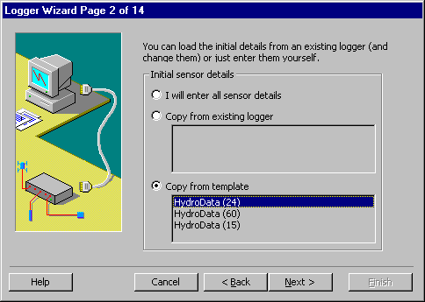
2) Click Next, and enter the logger name and number.
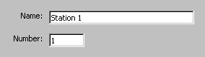
3) Click Next until you get to Page 7 of 14n and enter the name of the data file for this logger e.g. C:\MLOG\Hydrodat.DAT
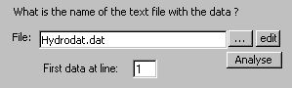

4) Click Next until you get to Page 7 of 14. Check that Campbell is selected, that the columns for date and ArrayID are correct, and enter the ArrayID number.
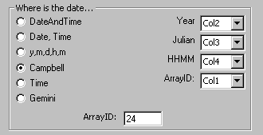
7) Click Next until you get to the end and click Finish.
Repeat for each logger, entering the corresponding data file for that logger.
Uploading
Use CSI software - (possibly could do with M-Log ???)
Support
Free telephone, fax and email support for the software is provided for 3 months. After that time you can either take out an annual support contract, or pay a charge for each problem.
A free email listserver is available – send questions to…
<rsne-l@rsne.com.au>
To subscribe, send an email to...
<majordomo@rsne.com.au>
With the message...
SUBSCRIBE rsne-l
The archives of the listserver are available at...
http://www.rsne.com.au
Software updates and other files for downloading are at...
http://www.rsne.com.au/mlog/upgrades.htm

Australia: Research Services New England
e: support@rsne.com.au
t: +61 (2) 9810 3563 f: +61 (2) 9810 3323

China: Aozuo Ecology Instrumentation
e: sales@aozuo.com.cn
t: +86 (10) 6897 5237 f: +86 (10) 6897 5235

Hydrodata
PO Box W157, Dubbo, NSW 2830, Australia
T/F: +61 (2) 6885 4119 m: +61 04 1985 4119
E: hydrodat@lisp.com.au W: www.hydrodata.com
Campbell Scientific
T: +1 (1???) ??? F: +44 (1638) 74 3155
E: sales@campbellsci.com W: http://www.campbellsci.com

Research Services New England
8/16 Nicholson Street, Balmain, NSW 2041, Australia
T: +61 (2) 9810 3563 F: +61 (2) 9810 3323
E: support@rsne.com.au W: www.rsne.com.au

