Goanna Telemetry use Campbell Scientific data loggers, which M-Log can graph. Data is downloaded from the loggers using CSI software and is left in a comma-delimited file. The date is saved as Year, DayOfYear (julian) and the time as hhmm. Each data file can contain information from several different Enviroscan tubes or Campbell weather stations, and the ArrayID at the beginning of the line identifies the data.
Installing M-Log
- Install M-Log from CD (D:\MLOG\SETUP.EXE) with...
- Click on Start
- Choose Run
- Enter D:\MLOG\SETUP.EXE (or use <Browse>)
- Follow the setup wizard with Next, Next
- If supplied, install M-Log upgrade from disk (A:\UPGRADE.EXE)
3. Run M-Log from Start/Menu or icon.
The sample database of loggers and sensors will be listed - click on a sensor to plot the sample data.
Registration
M-Log can be used for 30 days, but after that time needs registering to allow changes you make to be saved.
- Use FileMenu/Registration
- Email or fax the PC Serial number and you will be sent a password.
- Enter the password and click <Activate>
Create a new database for your loggers
To create a new database for your data use FileMenu/New/Database, and choose C:\MLOG\MLOG1.MDB.
Alternatively you can add new loggers to an existing M-Log database.
Creating New Loggers
A ‘logger’ is an Enviroscan tube (ArrayID=30) or a weather station. The data file from the logger will contain both daily summary data (ArrayID=24) as well as hourly data (ArrayID=60), and separate ‘loggers’ need creating for the daily and hourly data.
Use FileMenu/New/Logger and a wizard will run, allowing you to create a new logger by copying a template logger.
- Click Next to get to Page 2 of 14.
- Choose Copy from Template
- Use <..> and choose Goanna.MDB as the template file.
- Choose a logger to copy.
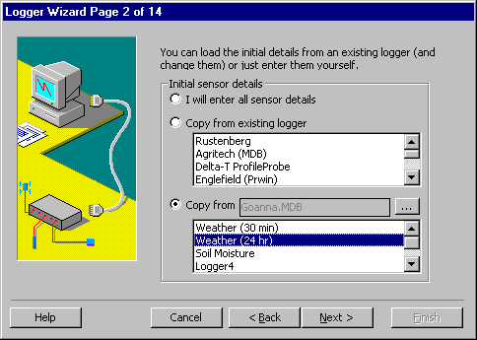
2) Click Next, and enter the logger name and number.
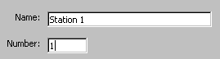
3) Click Next until you get to Page 7 of 14 and enter the name of the data file for this logger e.g. C:\MLOG\2002\station1.dat
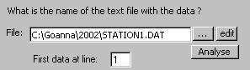

4) Click Next until you get to Page 7 of 14. Check that Campbell is selected, that the columns for date and ArrayID are correct, and that the the ArrayID number is correct.
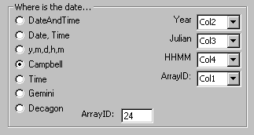
7) Click Next until you get to the end and click Finish.
Repeat for each logger, entering the corresponding data file for that logger.
Uploading
Use Campbell software (M-Log will be available)
Support
Free telephone, fax and email support for the software is provided for 3 months. After that time you can either take out an annual support contract, or pay a charge for each problem.
Software updates and other files for downloading are at...
http://www.rsne.com.au/mlog/upgrades.htm

Australia: Research Services New England
e: support@rsne.com.au
t: +61 (2) 9810 3563 f: +61 (2) 9810 3323

Goanna Telemetry
PO Box 782
Gondiwindi, QLD 4390
T: +61 (7) 4671 5155 F: +61 (7) 4671 4099
E: sales@goanna.com.au W: www.goanna.com.au

Research Services New England
8/16 Nicholson Street, Balmain, NSW 2041, Australia
T: +61 (2) 9810 3563 F: +61 (2) 9810 3323
E: support@rsne.com.au W: www.rsne.com.au

