M-Log can graph data from the Enviropro Soil moisture system., manfactured by Envirotek. Data is downloaded from the field units using Tek-Link software, and is left in a comma-delimited file.
Installing M-Log and Tek-Link
- Install M-Log from CD (D:\SETUP.EXE) with...
- Click on Start
- Choose Run
- Enter D:\SETUP.EXE (or use <Browse>)
- Follow the setup wizard with Next, Next
- Install Tek-Link from CD (D:\TekLink\SETUP.EXE).
- Run M-Log from Start/Menu or icon.
- Run Tek-Link from Start/Menu or icon.
To view the Enviropro sample data
Use FileMenu/Open and choose C:\Mlog\TekSmart.MDB.
Sample sites and sensors will be shown - click on a sensor to plot the data.
Configuring Tek-Link
Use Windows Explorer to create a folder C:\Mlog\2004 for the downloaded data files. For each following season you could create a new folder called, say, C:\Mlog\2005.
Run Tek-Link. On the files tab use <...> to find the folder C:\Mlog\2004.
See the Tek-Link manual for full details.
Download some data from your Enviropro units. This will automatically create data files for each unit so that when you create a ‘logger’ in M-Log for each site a data file already exists for the site.
Registration
M-Log can be used for 30 days, but after that time needs registering to allow changes you make to be saved.
- Use FileMenu/Registration
- Email or fax the PC Serial number and you will be sent a password.
- Enter the password and click <Activate>
Create a new database for the Field Units
Use FileMenu/New/Database to create a new database for your data. You will be asked to enter a name for the database e.g. C:\Mlog\ABC2004.MDB.
Alternatively, you can add new loggers to an existing M-Log database.
Creating new loggers for each Field Unit
You need to create a logger for each Enviropro soil moisture unit. Use FileMenu/New/Logger, and a wizard will run, allowing you to create a new logger by copying a template logger.
- Click Next to get to Page 2 of 14.
- Choose Copy from Template
- Use <..> and choose C:\Mlog\TekSmart.MDB as the template file.
- Choose a logger to copy.
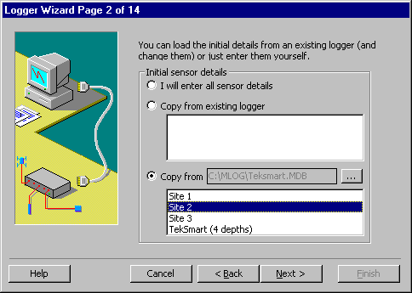
2) Click Next, and enter the logger name and number.
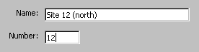
3) Click Next until you get to Page 7 of 14 and enter the name of the data file for this logger e.g. C:\MLOG\2004\U0001.TXT
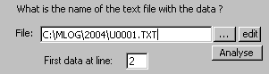

7) Click Next until you get to the end and click Finish.
Repeat for each logger, entering the corresponding data file for that logger.
New Season
To prepare for a new season...
1 Use Explorer and create a new folder for the new seasons data.
e.g. C:\Mlog\2005.
2 Run Teklink. On the file tab, use the <...> to locate this folder.
Use <download> to create a data file for each Enviropro.
3 Run M-Log. Use FileMenu/New/Logger to create a logger for each Enviropro. Change the folder for the data file to be the new season data folder.
Support
Free telephone, fax and email support for the software is provided for 3 months. After that time you can either take out an annual support contract, or pay a charge for each problem.
Software updates and other files for downloading are at...
http://www.rsne.com.au/mlog/upgrades.htm
http://www.rsne.com.au/teklink/upgrades.htm

Enviropro
PO Box 40, Lyrup, SA 5343, SA 5210, Australia
T: 0438 821 593
F: (08) 8582 3709
E: info@envirotek.com.au
W: www.envirotek.com.au

Research Services New England
8/16 Nicholson Street, Balmain, NSW 2041, Australia
T: +61 (2) 9810 3563
F: +61 (2) 9810 3323
E: support@rsne.com.au
W: www.rsne.com.au

