M-Log can graph data from the Decagon EM5 logger. Data is downloaded from the loggers using Decagon EchoLink software and is left in a comma-delimited file. The date is saved as Year, DaysSinceJan2000 and the time as hhmm. A LoggerID is also saved, and can indicate different loggers.
Installing M-Log
- Install M-Log from CD (D:\MLOG\SETUP.EXE) with...
- Click on Start
- Choose Run
- Enter D:\MLOG\SETUP.EXE (or use <Browse>)
- Follow the setup wizard with Next, Next
- If supplied, install M-Log upgrade from disk (A:\UPGRADE.EXE)
3. Run M-Log from Start/Menu or icon
The sample database of loggers and sensors will be listed - click on a sensor to plot the sample data.
Configure EchoLink
Install EchoLink software from CD.
Use Windows Explorer to create a folder C:\Mlog\Echo\Data2003 for the downloaded data.
For each following season you could create a new folder called, say, C:\Mlog\Echo\Data2004.
Configure EchoLink to use this folder with FileMenu/Save as ???.
Download some data so that when you create a ‘logger’ for each site a data file already exists for the site.
Registration
M-Log can be used for 30 days, but after that time needs registering to allow changes you make to be saved.
- Use FileMenu/Registration
- Email or fax the PC Serial number and you will be sent a password.
- Enter the password and click <Activate>
Create a new database for your loggers
To create a new database for your data use FileMenu/New/Database, and choose C:\Mlog\Echo\Mlog1.MDB.
Alternatively you can add new loggers to an existing M-Log database. New loggers and sensors will be created after readings are uploaded.
Creating New Loggers
Use FileMenu/New/Logger, and a wizard will run, allowing you to create a new logger by copying a template logger.
- Click Next to get to Page 2 of 14.
- Choose Copy from Template
- Use <..> and choose C:\Mlog\ICT.MDB as the template file.
- Choose a logger to copy.
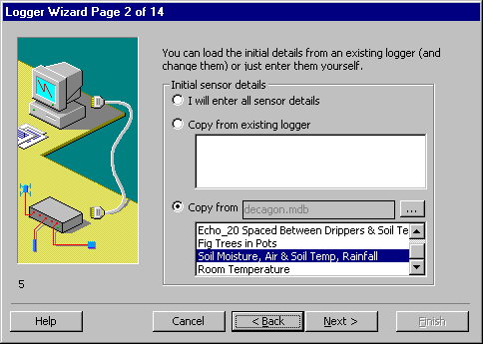
2) Click Next, and enter the logger name and number.
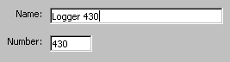
3) Click Next until you get to Page 7 of 14 and enter the name of the data file for this logger e.g. C:\MLOG\2002\EL419.TXT
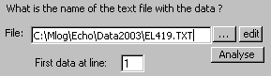

4) Click Next until you get to Page 7 of 14. Check that Decagon is selected. If the data file contains data from different loggers at ArrayID enter the LoggerID. and set StationID: Col1.
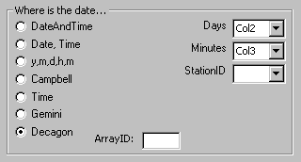
7) Click Next until you get to the end and click Finish.
Repeat for each logger, entering the corresponding data file for that logger.
Uploading
Use Decagon EchoLink software.
Calibrations
The data in the Decagon file needs to be converted to user units. Calibration factors are entered at LoggerMenu/Details/SensorImport tab.
The factors required for Decagon sensors are...
Sensor | Slope | Intercept
Echo_10 | 0.057 | -37.6
Echo_20 | 0.0424 | -29.0
Temperature | lookup file ElDegC.LKP (centigrade)  ElDegF.LKP (farenheit)

Support
Free telephone, fax and email support for the software is provided for 3 months. After that time you can either take out an annual support contract, or pay a charge for each problem.
Software updates and other files for downloading are at...
http://www.rsne.com.au/mlog/upgrades.htm

ICT International Pty Ltd
PO Box 503, Armidale, NSW 2350, Australia
T: +61 (2) 6772 6770
F: +61 (2) 6772 7616
E: sales@ictinternational.com.au
W: www.ictinternational.com.au

Research Services New England
8/16 Nicholson Street, Balmain, NSW 2041, Australia
T: +61 (2) 9810 3563
F: +61 (2) 9810 3323
E: support@rsne.com.au
W: www.rsne.com.au

Decagon Devices Inc
950 NE Nelson Court
Pullman, WA 99163 USA
T: +1-800-755-2751
F: 509-332-5158
E: sales@decagon.com
W: www.decagon.com

